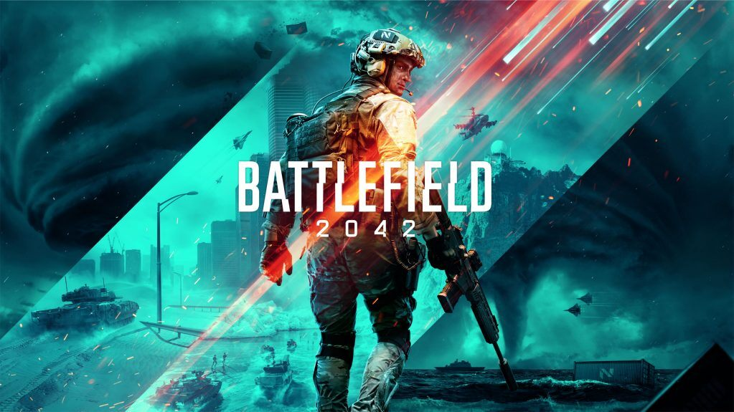

**BATTLEFIELD 2042**

**Developed By:**[DICE](https://www.google.com/search?bih=625&biw=1366&hl=en&sxsrf=AOaemvIxzVHMNkXbuItfxgf4xdrh6WF2LQ:1640623480086&q=EA+DICE&stick=H4sIAAAAAAAAAOPgE-LVT9c3NCw0yo03Log3UOLUz9U3MEo3LTPSUslOttJPLkvXT87PLSgtSS2KL8tMSc1PT8xNtUpJLUvNyS9ILVrEyu7qqODi6ey6g5URAGB9bIRPAAAA&sa=X&ved=2ahUKEwjD4fXdtoT1AhU6SfEDHbCQACoQmxMoAXoECDwQAw&cshid=1640623505849873)

**Description:** Battlefield 2042 is a first-person shooter video game developed by DICE and published by Electronic Arts. Unlike recent Battlefield games, Battlefield 2042 is solely multiplayer and does not have a single-player campaign. It also features support for cross-platform play, a first in the series.

**Platforms:** Xbox Series X and Series S, PlayStation 4, PlayStation 5, Xbox One, Microsoft Windows

**System Requirement:**

* A minimum computer system that will help you access all the tools in the courses is a Pentium 166 or better.
* 64 Megabytes of RAM or better.

**Published By:**

